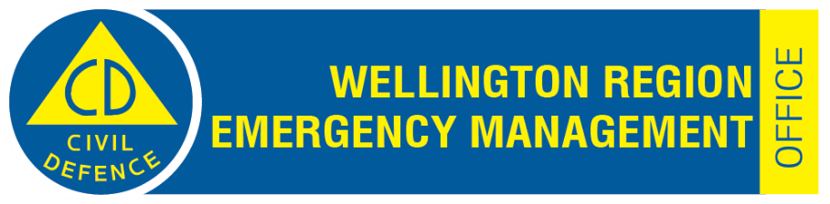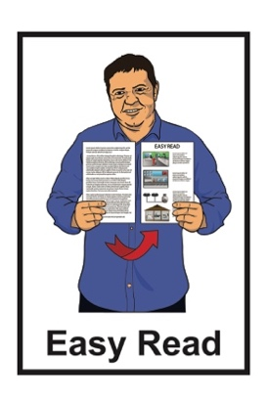

Storing water to use in an emergency

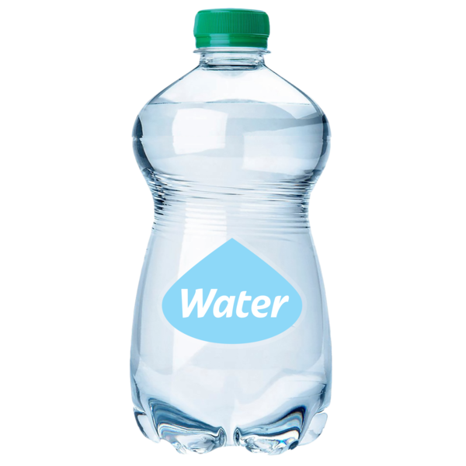

Published: May 2024

# About this document

This Easy Read document is about **storing** water to use in an **emergency**.

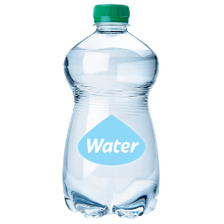

**Storing** means putting away for later.

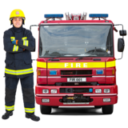An **emergency** is something bad that happens that needs to be taken care of right away.

Emergencies are things like:

fires

floods

earthquakes.

# Why you need to store water at home

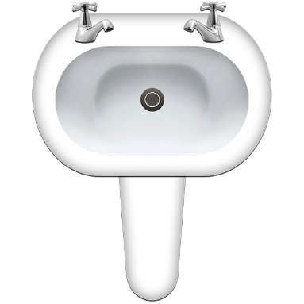

You need to store water because in an emergency there may not be fresh water.

Water is needed for lots of things like:

drinking

washing

cooking

first aid

taking care of pets.

Different parts of the country need to store different amounts of water.

This document talks about how much water you need to store in the **Wellington Region.**

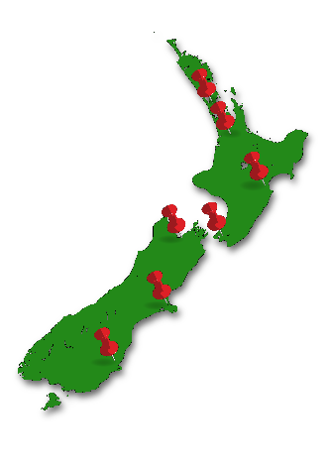

The **Wellington Region** means:

Wellington City

Lower Hutt

Upper Hutt

Porirua

Kāpiti

the Wairarapa.

# How much water do you need to store?

You need to store 7 days worth of water for each person in your house.

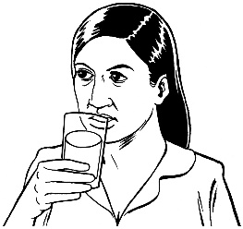

**20L**

Each person needs about 20 litres of water each day.

It is best to store at least 140 litres of water for each person who lives in your house.

**140L**

This amount means you should have enough water for:

drinking

cooking

washing yourself with a cloth.

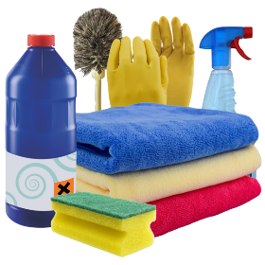This amount means you should also have enough water for:

washing dishes

brushing your teeth

washing clothes by hand

first aid

your pets.



You can store less water but you will not be able to do as much.

The smallest amount of water you should store is 3 litres of water for each day for each person.

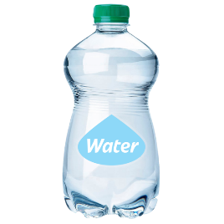

**3L**

**21L**



This means that for 7 days you will need to store 21 litres for each person.

Storing the smallest amount means you will only be able to use that water to:

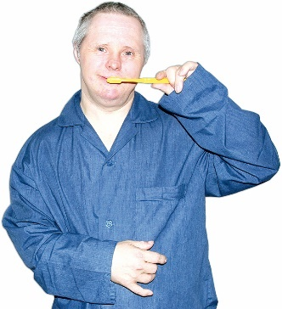drink

cook

clean yourself a little like brushing your teeth.

Some people will need more water than others like:

children

people who are breastfeeding

people who are sick.

# Water for your pets

Pets need water in an emergency for:

drinking

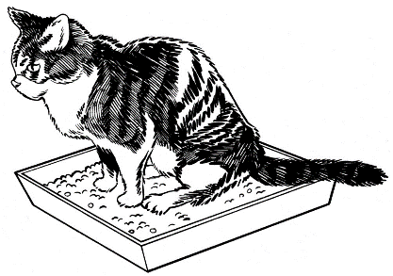you to clean up any mess they make.

Pets drink more water than normal when they are upset.

The amount of water you need for your pets will be different because of:

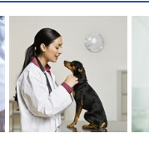how big they are – a cat will need less water than a large dog

any health problems they have.

# How to store water safely

There are a few ways to store water safely.

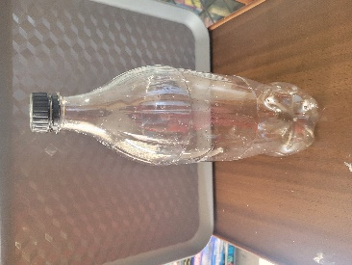You can store water in recycled containers like:

plastic water bottles

soft drink bottles.

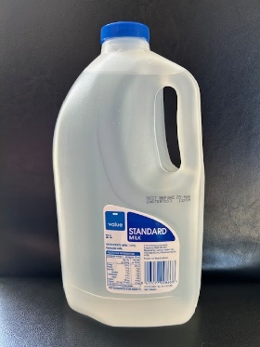

Do not store water in milk bottles because milk cannot be fully cleaned out of a milk bottle.

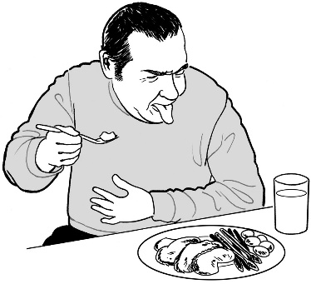This means that milk bottles can make the water go bad.

You can also fill clean ice cream containers with water to put in the freezer.

Putting ice cream containers of water into the freezer is good for an emergency because:

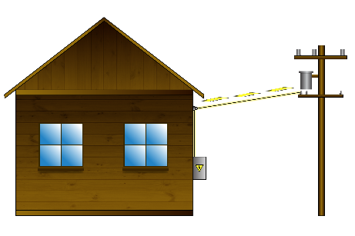

the large blocks of ice can keep food cool if the power is off

the ice can be used for drinking once melted.

Your hot water cylinder is a good place to get water in an emergency.

Make sure your hot water cylinder is held in place so that it will not break in an emergency.

You can also sometimes use the water from the cistern which is the tank at the top of your toilet.

You can only use the water from the cistern if you do not use chemical toilet cleaners in it.



Do not use any water in the bowl of the toilet which is where waste goes.

You can buy bigger containers to store water like:

200 litre household water tanks from your local council

larger water tanks from hardware stores

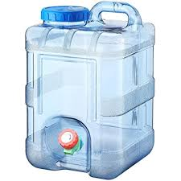 portable water containers from:

* hardware stores
* camping stores.

# Contact us

You can contact us if you have any questions about:



storing water

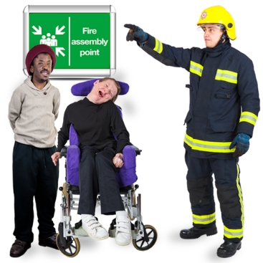how to be ready for an emergency.

You can contact us by:

* A white envelope with a black at symbol

  Description automatically generatedemail at:

**info@wremo.nz**

going to our website at:

**www.wremo.nz/water**

You can also contact us by phone on:

**04 830 4279**

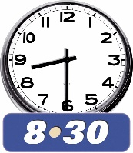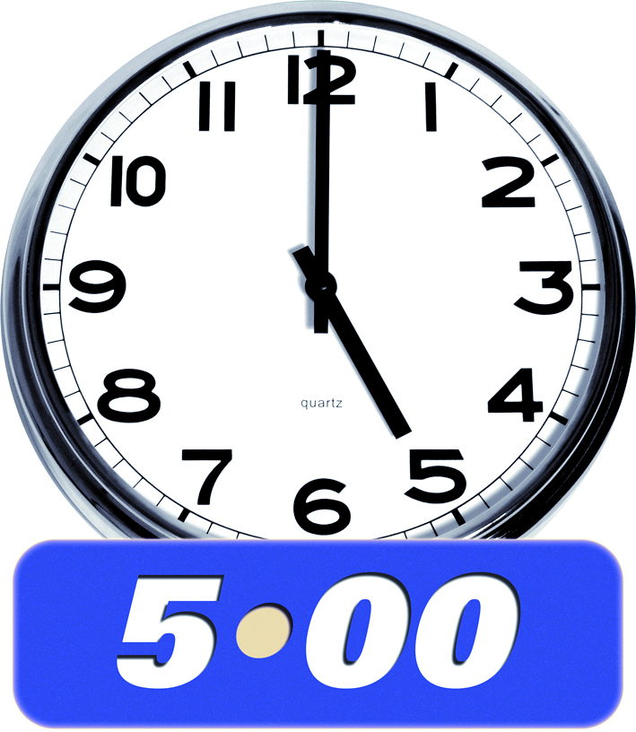

You can call us:

between 8:30 am and 5:00 pm

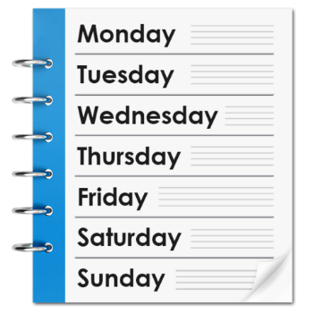

Monday to Friday.

If you find it hard to use the phone the **New Zealand Relay** service is for people who are:

* 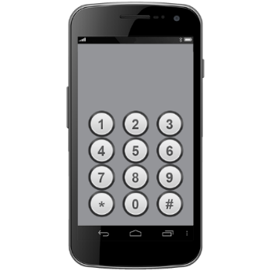Deaf / hard of hearing
* deafblind
* speech impaired / find it hard to talk.

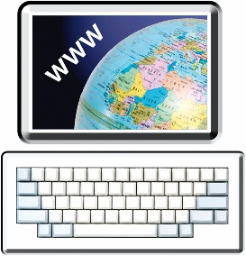You can find out more about the New Zealand Relay service at:

**www.nzrelay.co.nz**

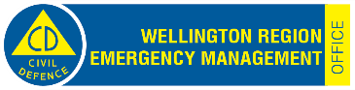This information has been written by Wellington Region Emergency Management.

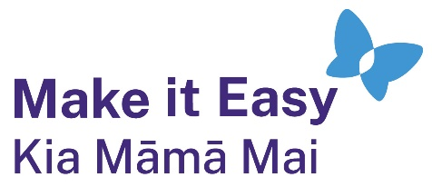It has been translated into Easy Read by the Make it Easy Kia Māmā Mai service of People First New Zealand Ngā Tāngata Tuatahi.



The ideas in this document are not the ideas of People First New Zealand Ngā Tāngata Tuatahi.

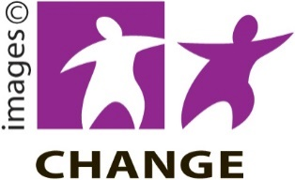

Make it Easy uses images from:

* Changepeople.org

Photosymbols.com

* SGC Image Works
* Huriana Kopeke-Te Aho
* T. Wood.

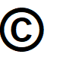  
All images used in this Easy Read document are subject to copyright rules and cannot be used without permission.